Measures of location and spread -Answers
May 2014 Mathematics Advanced Paper 1: Statistics 1

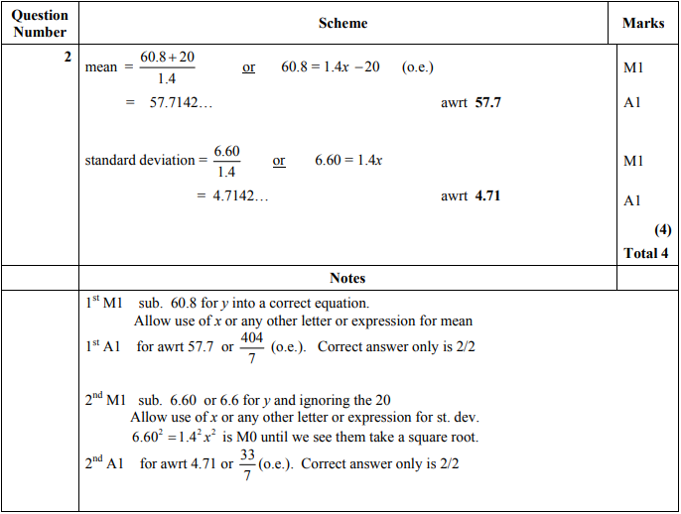

Jan 2012 Mathematics Advanced Paper 1: Statistics 1

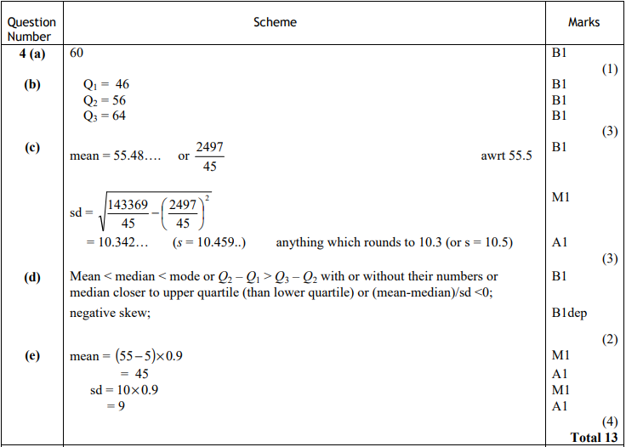
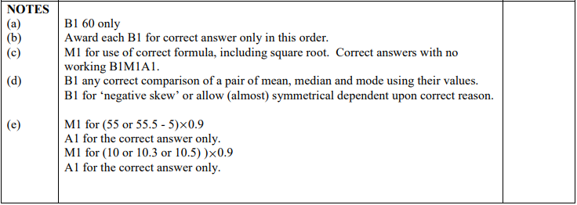

Jan 2011 Mathematics Advanced Paper 1: Statistics 1

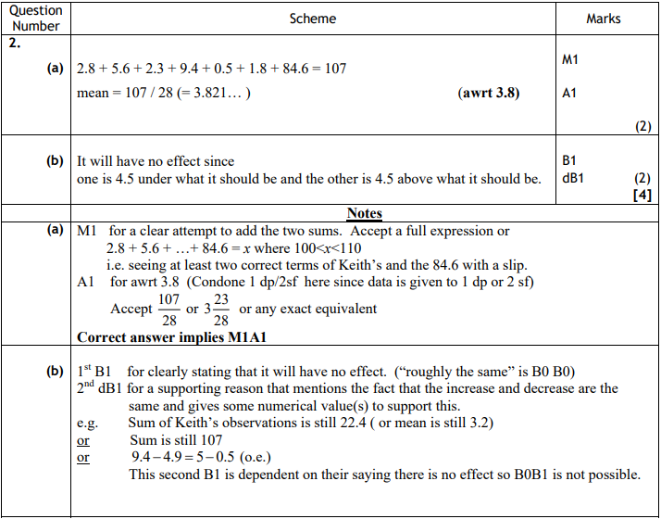

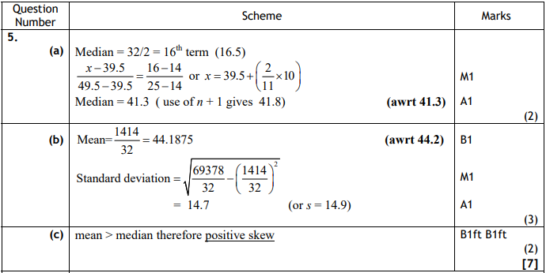
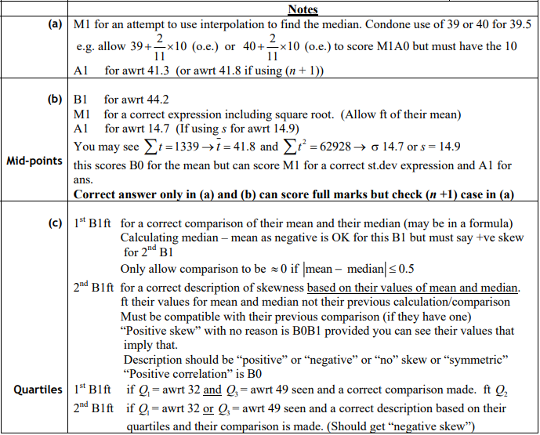

May 2010 Mathematics Advanced Paper 1: Statistics 1

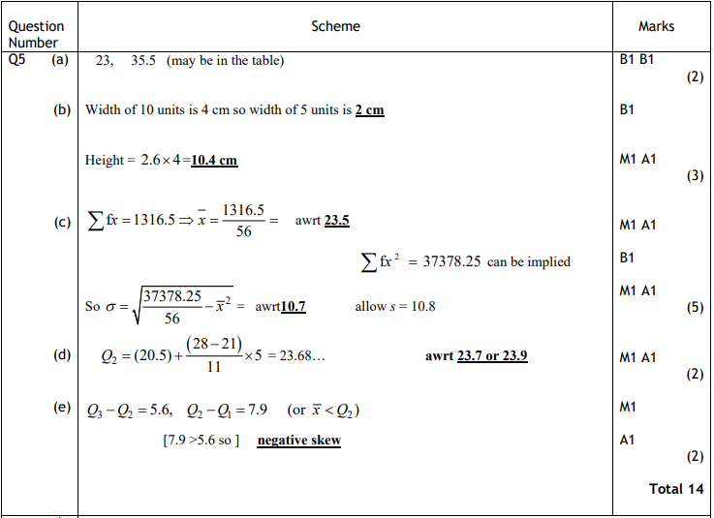
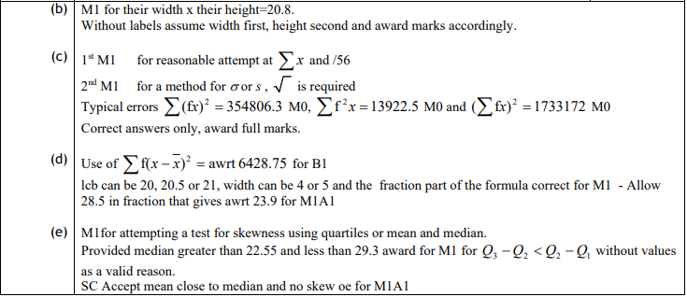

Jan 2010 Mathematics Advanced Paper 1: Statistics 1

